Data Import, Data Export, Preparation of charts and Simple Mathematical Operations using Google Collab
Aim: To learn how to import and export datasets, perform simple mathematical operations, and generate basic charts using Google Colab.

Requirements
- Software:
  - Google Colab (browser-based, requires Google account)
  - Python 3.x (pre-installed in Colab)
- Libraries:
  - Pandas
  - NumPy
  - Matplotlib
  - Seaborn
- Dataset:
  - concrete_data.csv file (any other .csv file)

Execution procedure with code:

Step 1: Open Google Colab. and Create a new notebook.

Step 2: Import Required Libraries

import pandas as pd

import numpy as np

import matplotlib.pyplot as plt

import seaborn as sns

Step 3: Import Dataset “concrete_data.csv” file (any other .csv file)
from google.colab import files
uploaded = files.upload()
df = pd.read_csv("concrete_data.csv")
df.head()

Step 4: Perform Simple Mathematical Operations like Mean, Maximum, Minimum
print("Average Cement content:", df['Cement (kg/m3)'].mean())
print("Maximum Strength:", df['Strength (MPa)'].max())
print("Minimum Water content:", df['Water (kg/m3)'].min())

Add new column: Water-Cement Ratio (w/c)

df['w/c'] = df['Water (kg/m3)'] / df['Cement (kg/m3)']
df

Step 5: Preparation of Charts
Bar Chart – Cement vs Strength
plt.figure(figsize=(6,4))
plt.bar(df['Mix_ID'], df['Strength (MPa)'], color='skyblue')
plt.xlabel('Mix ID')
plt.ylabel('Strength (MPa)')
plt.title('Concrete Strength for Different Mixes')
plt.show()

Output:
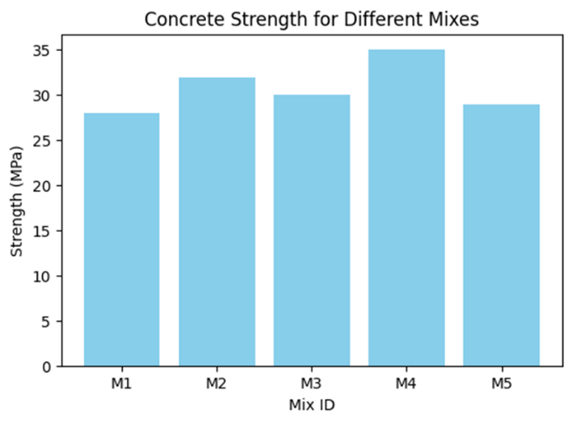

Scatter Plot – Water-Cement Ratio vs Strength
plt.figure(figsize=(6,4))
sns.scatterplot(x='w/c', y='Strength (MPa)', data=df, s=100, color='red')
plt.title('Effect of w/c Ratio on Strength')
plt.show()

Output:
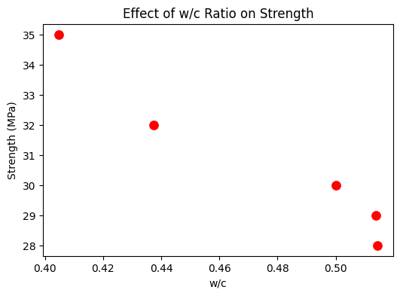
Step 6: Export Processed Dataset
Save updated dataframe with new column (w/c ratio)

df.to_csv("processed_concrete_data.csv", index=False)
files.download("processed_concrete_data.csv")

Final Output:

Mix_ID | Cement (kg/m3) | Water (kg/m3) | Fine_Aggregate (kg/m3) | Coarse_Aggregate (kg/m3) | Strength (MPa) | w/c
M1 | 350 | 180 | 650 | 1200 | 28 | 0.514286
M2 | 400 | 175 | 700 | 1100 | 32 | 0.4375
M3 | 380 | 190 | 680 | 1150 | 30 | 0.5
M4 | 420 | 170 | 720 | 1120 | 35 | 0.404762
M5 | 360 | 185 | 690 | 1180 | 29 | 0.513889

Viva Questions

- What are the advantages of using Google Colab for data analytics?
- Explain how CSV files are read and written in Python.
- Why is water-cement ratio important in concrete mix design?
- Differentiate between bar chart and scatter plot.

